LAB SETUP
TOPICS COVERED: Ethernet, IP Addresses and Subnetting, CIDR Notation, ARP, ICMP, Switch, Router, Static routing, Routing tables, Next-hop addresses
, Return routes, Multi-network troubleshooting.
Lab Components :
- 2 Routers (2911).
- 2 Switchs (2960).
- 2 PCS (PC-PT).
Lab Setup :
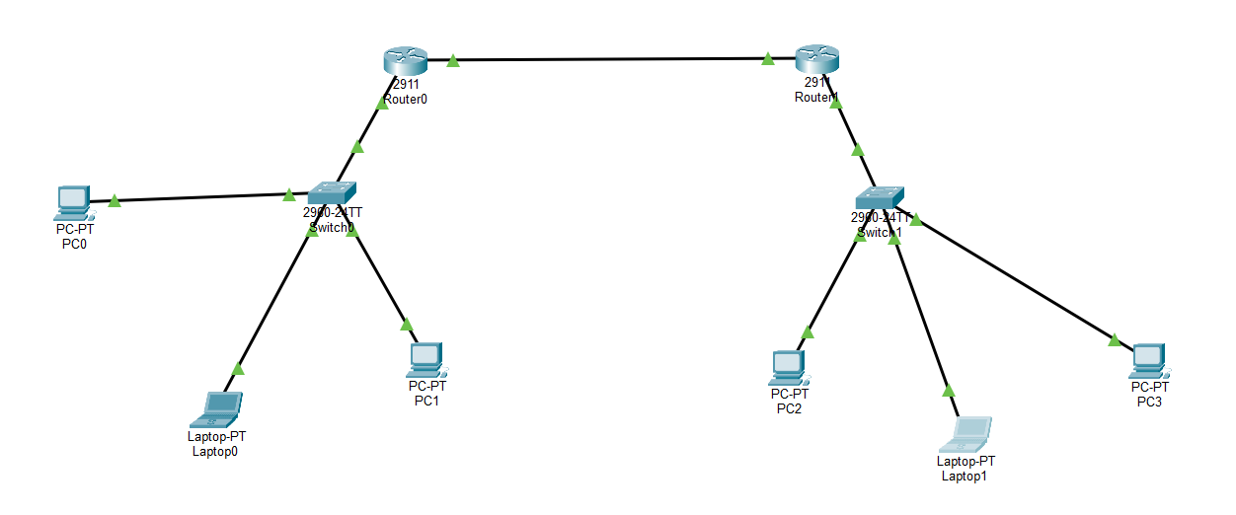

Lab Configuration :
- Drag and drop the lab components.
- Connect
Device A | Interface | Device B | Interface
R1 | GigabitEthernet 0/0 | S1 | GigabitEthernet 0/1
PC1 | FastEthernet 0 | S1 | FastEthernet 0/1
PC2 | FastEthernet 0 | S1 | FastEthernet 0/2
PC3 | FastEthernet0 | S1 | FastEthernet 0/3
R2 | GigabitEthernet 0/0 | S2 | GigabitEthernet 0/1
PC1 | FastEthernet 0 | S2 | FastEthernet 0/1
PC2 | FastEthernet 0 | S2 | FastEthernet 0/2
PC3 | FastEthernet0 | S2 | FastEthernet 0/3
R1 | GigabitEthernet 0/1 | R2 | GigabitEthernet 0/1
- Click Router 1 -> CLI tab. If prompted to enter the initial configuration dialog, type no and enter the following commands:
enable
config terminal
hostname R1
interface gigabitEthernet 0/0
ip address 192.168.10.1 255.255.255.0
no shutdown
exit
interface gigabitEthernet 0/1
ip address 10.0.0.1 255.255.255.252
no shutdown
exit
- Click Router 1 -> CLI tab. If prompted to enter the initial configuration dialog, type no and enter the following commands:
enable
config terminal
hostname R2
interface gigabitEthernet 0/0
ip address 192.168.20.1 255.255.255.0
no shutdown
exit
interface gigabitEthernet 0/1
ip address 10.0.0.2 255.255.255.252
no shutdown
exit
- Configuring static routes between both routers.
R1 -> ip route 192.168.20.0 255.255.255.0 10.0.0.2
R2 -> ip route 192.168.10.0 255.255.255.0 10.0.0.1
- Configuring network settings for the PCs.
Router 1 :
Setting | PC1 | PC2 | PC3
IP address | 192.168.10.11 | 192.168.10.12 | 192.168.10.13
Subnet mask | 255.255.255.0 | 255.255.255.0 | 255.255.255.0
Default gateway | 192.168.10.1 | 192.168.10.1 | 192.168.10.1

- Router 2 :
Setting | PC1 | PC2 | PC3
IP address | 192.168.20.11 | 192.168.20.12 | 192.168.20.13
Subnet mask | 255.255.255.0 | 255.255.255.0 | 255.255.255.0
Default gateway | 192.168.20.1 | 192.168.20.1 | 192.168.20.1
- Understand the routing tables
On R1:
show ip route
You should see:
C — directly connected networks.
L — local interface addresses.
S — static routes.
R1 should have a static route to 192.168.20.0/24.
On R2, run the same command. It should have a static route to 192.168.10.0/24.
Key Networking Concepts Learned :
Lab 2: Connecting Two Different Subnets Using Two Routers
The main objective was to understand how devices in different networks communicate through multiple routers.
Here are the 10 key concepts you should take away from this lab.
1. Subnetting
Subnetting means dividing a larger IP address space into smaller networks.
You created three networks:
Network | Purpose
192.168.10.0/24 | Administration LAN
10.0.0.0/30 | Router-to-router connection
192.168.20.0/24 | Engineering LAN
2. CIDR notation
CIDR tells us how many bits are used for the network portion of an IP address.
- /24 = 255.255.255.0
- /30 = 255.255.255.252
You learned that different networks can have different subnet masks.
3. Point-to-point connection
You connected R1 and R2 using a separate network: 10.0.0.0/30.
This network provides two usable IP addresses:
- R1: 10.0.0.1
- R2: 10.0.0.2
4. Default gateway
A default gateway is the router interface that a device uses to communicate with other networks.
- PC1 gateway: 192.168.10.1
- PC2 gateway: 192.168.20.1
Without the correct gateway, a PC cannot properly communicate with remote networks.
5. Static routing
Static routing means manually configuring a router to reach a remote network.
On R1:
ip route 192.168.20.0 255.255.255.0 10.0.0.2
On R2:
ip route 192.168.10.0 255.255.255.0 10.0.0.1
6. Routing table
You learned to inspect a router's routing table using:
show ip route
Three important route types:
Code | Meaning
C | Directly connected
L | Local interface address
S | Static route

7. Next-hop address
The next-hop address identifies the next router to which a packet should be forwarded.
For example, R1 forwards traffic for PC2's network to 10.0.0.2 (R2).
8. Return routing
Communication requires a working path in both directions.
Even if R1 knows how to reach PC2, R2 must also know how to reach PC1.
This is why both routers need static routes.
9. ARP resolution
ARP (Address Resolution Protocol) discovers the MAC address associated with an IPv4 address on the local network.
You also investigated why the first ping packet sometimes times out while subsequent packets succeed.
Remember: an initial timeout can be caused by ARP resolution, but repeated timeouts need further investigation.
10. Network troubleshooting
You practised using these commands:
Command | Purpose
ping | Test connectivity
show ip route | Inspect routing information
show ip interface brief | Check interface status
show ip arp | Inspect ARP mappings
ipconfig | Check PC IP configuration
Your Lab 2 knowledge summary
What you should now understand
- How to create separate IP networks using subnetting.
- How to connect two routers using a point-to-point network.
- How to configure IP addresses on router interfaces.
- How to configure default gateways on PCs.
- How to configure static routes between routers.
- How to read routing tables.
- Why routing must work in both directions.
- How ARP and ICMP contribute to network communication.
- How to troubleshoot connectivity problems.
The most important concept to remember
A router needs to know where to send a packet next.
For communication between PC1 and PC2:
PC1
|
R1
|
R2
|
PC2
Each router examines the destination IP address, checks its routing table, and forwards the packet towards the destination.
This is the foundation of IP routing.

